Supplying company desktop-application software requirement specification

# Ziad Mohamed 202000055

# Seif Khattab 202000478

# Omar Khaled 202000585

# Adham Youssef 202000246

# Abdelrhman Hossam 202001458

Chapter 1

### Purpose of the document:

The purpose of this document is to build a desktop-application for a supplying company which will be responsible for the management of the flow of goods, data, finances related to the product from the procurement of supplies from the supplier to the delivery of the product at its final destination.

### Scope of the project:

This desktop-application controls and manages the flow of goods, data, finances related to the product from the procurement of supplies from the supplier to the delivery of the product at its final destination. This project will ease the process of the data entry of the employees working at the company so it will help in time management and will reduce the effort. Each employee will have his own account on the application which will give him access to the feature and data related to his department. The system is based on a relational database system which will connect everything related to the company from exports, imports, finances, stock…… . There will be a database server that supports every PC in the company. Above all, we hope to provide a comfortable user experience along with the best pricing available.

### Technologies used:

Hardware:

* Laptop
* Database server
* PC

Software:

* Eclipse IDE
* MySQL Workbench

Programming Languages:

* Java
* JavaFX
* SQL

### Intended audience:

Project manager:

* Ziad Mohamed

Developers:

* Ziad Mohamed
* Adham Youssef
* Seif Medhat
* Omar Abdelaziz
* Abdelrahman Hossam

GUI designers:

* Adham Youssef
* Omar Abdelaziz

Testers:

* Seif Medhat
* Abdelrahman Hossam

*Scrum muster:*

* Seif Medhat

Product Owner:

* Omar Abdelaziz

Chapter 2

Overall Description

### Product Perspective:

* The desktop application is an independent system with a suitable user interface.
* The system has only one type of user but there are different types of employees who has different accesses. There are specific functions for each employee and every employee will have his own access according to his department.
* The system will have a database which contain all data.
* The application runs only on windows.

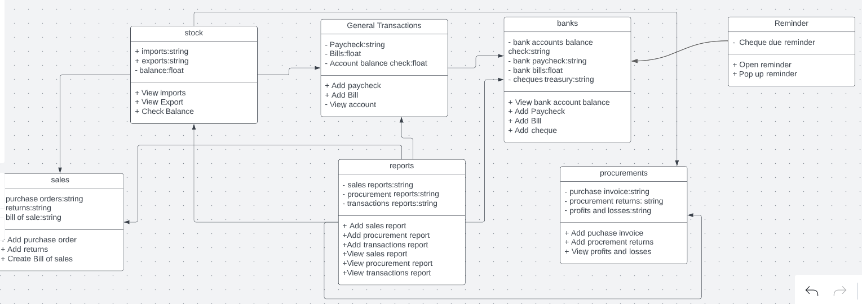

UML Diagram for supplying company Application

### User characteristics:

There is only one type of users can interact with the system, user of desktop application.

* The user can be any one of the company employees. User can use the system to do many functions as [ add purchase order, add bills, add paycheck, views imports and exports, etc.….].

This will be explained in detail in the following sections.

### Operating environment:

The system will run on Windows 7 or higher versions. It will be available on laptops and computers that supports windows OS only.

* For development we use windows OS.
* For deployment Computers are used.

### Constraints

The server is the main constraint of the project, which saves all data and supports the program inside the supplying company and connects all computers together. Without the server the program won’t be able to perform for the whole company data.

### Software constraints

* Languages used are C# plus WPF.
* The system will be supported by SQL database.

### Assumptions and dependencies

The app will be uploaded on the company’s computers and connected to the server.

* It’s assumed that all the users of the app will be one of the company’s employees who have access to this data.
* It is assumed that all people involved in the use of this app are connected to the server supporting this program.
* This system depends on a reliable database, which contains all data about the suppliers and clients and financial inquiries and quantities of goods inside the stock.

Chapter 3

Interfaces

### System interface

The employee of the desktop application should see the log-in page each time he opens the application; see Figure 01. If the employee is not registered in the system, he should be able to open the Register page; see Figure 02. So, he will create account to be able to use the functionalities of the system.

Figure 01

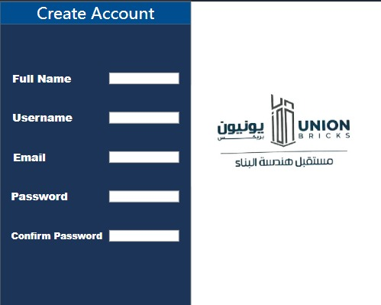

Figure 02

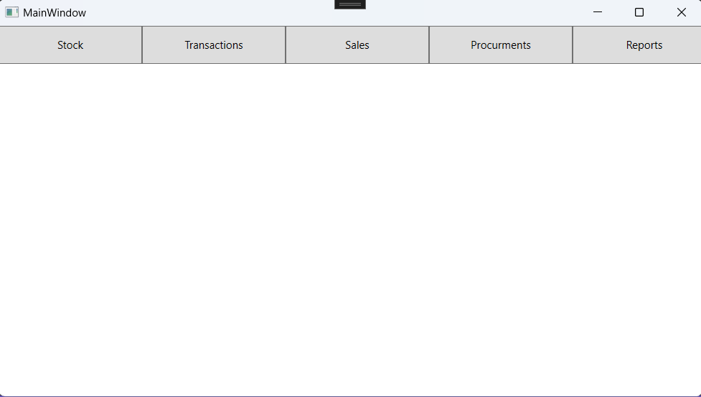­­­­­If the employee is logged in, he will see the home page; Figure 03 and will be able to choose from the panel at the top of the screen according to his department.

Figure 03

If the employee wants to check the products balances, he clicks on the stock button and navigate to the balance page; as in Figure 04.

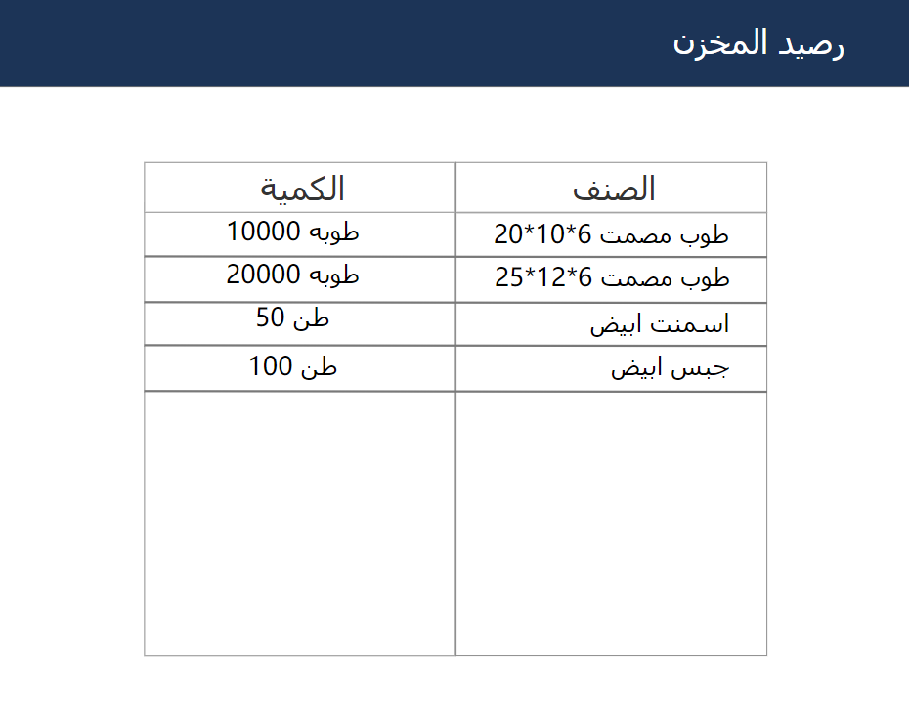

Figure 04

### Software interface

The supplying company app is a desktop application that will be developed under the windows operating systems environment using C# and WPF frame work. The system runs on windows 7 OS and higher versions. The system will be connected to a database system in the server side that the company will offer, using mySQL to run the data queries. The WPF frame work will be responsible for the GUI and the actions between buttons and page navigation and data entry. The application takes data entered by the employees and stores it in the database, therefore these data can be collected and checked later together when added all up.

### Hardware interface

The supplying company application is a desktop application that needs to store data so it can be checked later, therefore a based server will be needed in the company to connect all the computers together and add all the data up.

Chapter 4

*Functional Requirements*

**User Class 1 - The User**

**1.functional requirements**

Title: Register new Employee

Desc: System shall allow employees to be able to create a new account so they can log in later.

|  |
| --- |
| FR 1.1.1 User provides required info which includes: |
| 1. Full name 2. Username 3. Email address 4. Password 5. Confirm password |

**2.Functional requirements**

Title**:** Login.Desc**:** System shall allow the registered users to login by providing a valid username and valid password.

**3.Functional requirements**

Title: View balance

Desc: system shall allow the registered users to visualize the amount and type of products in stock.

**4.Functional requirements**

Title: Add new import form

Desc: system shall allow the registered employee to add a new form for a specific amount, price, type and imported date of product.

**5.Functional requirements**

Title: Save

Desc: system shall allow the registered employee to save any new or edited document; Export form, procurement report, purchase order.

**6. Functional requirements**

Title: Edit import form

Desc: system shall allow the registered employee to edit the amount, price, type and imported date product.

**7. Functional requirements**

Title: Delete

Desc: system shall allow the registered employee to delete any type of form; import, export, paycheck bill forms……

**8. Functional requirements**

Title: Print

Desc: system shall allow the registered employee to print any type of document; Import form, sales report, purchase invoice.

**9. Functional requirements**

Title: Search import form

Desc: system shall allow the registered employee to search for a specific import form using product type or form number.

**10. Functional requirements**

Title: add new selling order

Desc: system shall allow the registered employee to add new selling order for a specific amount, price, type of product and name of client.

**11. Functional requirements**

Title: add returns form

Desc: system shall allow the registered employee to add new form for a specific amount, price, type of returned product and name of client.

**12. Functional requirements**

Title: add bills of sales

Desc: system shall allow the employee to add bill of sales when the selling order is confirmed.

**13. Functional requirements**

Title: add new purchase invoice

Desc: system shall allow the employee to add new purchase invoice for a specific amount, price, type of product and name of supplier.

**14. Functional requirements**

Title: add new procurements returns

Desc: system shall allow the registered employee to add new form for a specific amount, price, type of returned product and name of supplier.

**15. Functional requirements**

Title: add new paycheck

Desc: system shall allow the registered employee to add new form with the specific money that the company will pay for [supplier, employees, etc.……]

Functional requirements

Title: View sales report

Desc: system shall allow the registered employee to view sales report according to a specific period of time or client or product.

Functional requirements

Title: View procurement report

Desc: system shall allow the registered employee to view procurement report according to a specific period of time or supplier or product.

Functional requirements

Title: View transactions report

Desc: system shall allow the registered employee to view procurement report according to a specific period of time, it includes amount of earned money and expensed money.

Bank

Functional requirements

Title: Check bank account balance

Desc: system shall allow the user to check the balance of any bank account of the company.

Functional requirements

Title: Add new bank bill

Desc: system shall allow the user to add a new bank bill.